Students‘ Creative Work

Lukrecija Abaravičiūtė IIC

In 1884–1888 Counts Tiškevičiai built me, a pier for merchant ships in Palanga. Juozapas Tiškevičius invested funds in maritime transport. He was hoping to make a profit from me. Juozapas wanted me to help trade in bricks, which he produced in his own brick house in Palanga. The Tiškevičiai steamer „Feniksas“ was moored to me to exporting bricks to Liepoja .Also the tourists were travelling to the city through me. I was built nearby the Rąžė estuary. They build me 1km long and in the shape of the letter L. It soon became clear that I was unsuitable for the port , because the sea bottom was too shallow. Later, my friend Feniksas, boat of the Tiškevičiai was sold and I i became another place to entertain vacationers. Now, in 2020, I‘m one of the most visited places in Palanga and Ii‘m really proud of the journey Ii have been through.

Ugnė Baltrimaitė IIC

Sea Pier in Palanga

Reaching into the sea for 407 metres and I‘m shaped in the form of letter L. I provide a chance to see the shore from a different perspective while going for a walk, at the same time, I‘m still opened for small tourist ships in summer.

I was first constructed in 1884, in order to revive Palanga port. The steamship that was also purchased at the time allowed to successfully transport passengers and different goods to the port of Liepāja (Latvia). Unfortunately, soon it became impossible to navigate due to the sand that was brought closer to me during storms.

After year 1888 I gained popularity as a place to visit while going for a walk, which established a new meaning for me. Strong winds and waves of the sea were damaging me over time, therefore, reconstruction was carried out in 1998. After the reconstruction I became an even more popular place among locals and city guests.

Ignas Abelkis IIC

I am really old, I was built in the 19th century and haven't died yet. I was also rebuilt a few times. My first owner was countess Sofia until two brothers bought me. Like I've mentioned before, I was rebuilt, my second owners made me larger and taller. In the 20th century they rebuilt me again, they put back my missing pieces and made me stronger. Now I am one of the most beautiful buildings in Palanga. A lot of people come to visit me because I am being used as a museum to showcase all of all kinds of exhibits. I have been in this one certain place for so long that I have seen so many things change in Palanga. A few days ago a group of teenagers with an English teacher came to see the exhibits. I think the group of teenagers were doing some sort of a task for their English class. I hope they get good grades.

Kotryna Baltrušaitytė IIC

Story about the observatory

It all started when I was built in the 1980s according to the architecture of two people - a husband and a wife. I was quite a challenge for people who wanted to turn me into a useful building - an observatory. To build an observatory requires a lot of knowledge and effort. Particular attention is paid to the dome at the top of the tower, in order for it to function properly and rotate synchronously with the telescope. Unfortunately, my situation is quite the opposite. When the dome was built, it began to deform, then, when people lost hope of repairing it, they boiled it, so I, as an observatory, was never opened.

In 1991, here, next to the tower, in the premises, a primary school was established, thus filling the empty and unused parts of me. The school still exists to this day, and I was left like an old object belonging to the city of Palanga and the hope of the people that I will have the opportunity to revive and become a thing that has not been fulfilled so far - an observatory.

Viltė Daratytė IIC

The Story of the Pier of Palanga

My life started in 1882, when a count named Juozapas Tishkevichius built me – a 900 step bridge- for brick transportation and, for as long as I can remember, I’ve been Palanga’s pride and joy. Hundreds of people step on my wooden planks every day, savoring the fresh breeze from the Baltic Sea and it is known that I’m a remarkable spot for fishermen, as the Baltic Sea has a huge variety of the inhabitants of the water. Oh, the stories I’ve heard and the sights I’ve seen… I have also served as a dock, mostly for a steamship called “Phoenix”, which travelled the route Palanga- Liepoja two times a week, carrying tourists, goods and bricks. But my life hasn’t always been that great. On the 18th of October in 1967, I was demolished by a raging hurricane and the coast of Palanga was flooded. It was a tragedy, as I was only left with poles peeping out of the water. I was, of course, rebuilt and continued to bring people joy. But, during a storm in 1993, I was destroyed by the powerful sea yet again, leaving me with a length of only 5 metres out of 380. The reconstruction works lasted three years and in 1997 I was reborn as a 461 m long structure on the coast of Palanga, Lithuania’s resort. And that’s my life story as the Bridge of Palanga.

I am exactly 900 steps or 380 metres long.

Jonas Endzinas IIC

Poem

As I’m walking through the front door

I sense the building’s heart roar.

The blue skies, melting with the roof tiles

The vibrance of its old times.

Walking through the history

as if nothing ever mattered to me.

The squeaking of its vintage stairs

sounding like a bonding to my ears.

Looking at its treasury

observing what it’s meant to be.

A penny on the right telling me

about the times he had more than me

The moonshine fading with the city lights

reminding that it’s time to leave.

A house in the other street

wishing he could be more like me.

The time has come for me to leave

saying bye to history.

A never ending cycle begins

of people visiting Anapilis.

Rugilė Grikšaitė IIC

The story of a Swimsuit

I was sewn from dark blue cotton fabric and consisted of three main parts. My long sleeved lovely dress with buttons, loose, barely reaching ankle pants and little shoes covered the elegant woman's body. She brought me to the resort of Palanga from the noisy city and she was in the mood to rest. I was brand new, never worn and was so excited to see the Baltic sea for the first time. When that beautiful woman put me on, I was so surprised how amazing the color of the water was, how relaxing the sound of the sea was and I liked to see the birds flying above us. Later she lay down and I felt a gentle touch of sand. I was so glad to be her first swimsuit, the first with whom she felt the sun rays.

Raminta Kairytė IIC

The story of the kurhaus

My journey started in 1877 when I was built in Palanga in the corner of the current Vytautas and J. Basanavičiaus streets. The beginning of my history is associated with the dynasty of Counts Tiškevičiai. The cCount Tiškevičius inniciated the construction work of me. At first spacious restaurants were built, which were soon expanded. Later I became the first resort hoteI in Palanga. I became a more and more popular and popular gathering place for holidaymakers, because I not only had a restaurant, but also a reading room, billiards and other game rooms. Almost every evening I could see people dancing, performing and that made me really excited. I didn't even notice how I became the heart of the emerging resort. I had an information office on the ground floor, where my resort fee was collected. Sadly, in 2002 on August 25th I was burned down. But luckily in during a the year my brick part was restored and even my authentic details were recovered. I was so happy that the builders did everything, even the smallest details. To this day I am a space for professionally performing arts. I can listen to a wide variety of music genres like: chamber, choral, jazz, folk. Also, a few days ago my wooden part, which was burned in the fire and was rebuilt, was opened. And that is the story of me, a resort symbol Kurhaus, which can be found in a beautiful town Palanga.

Martina Juškevičiūtė IIC

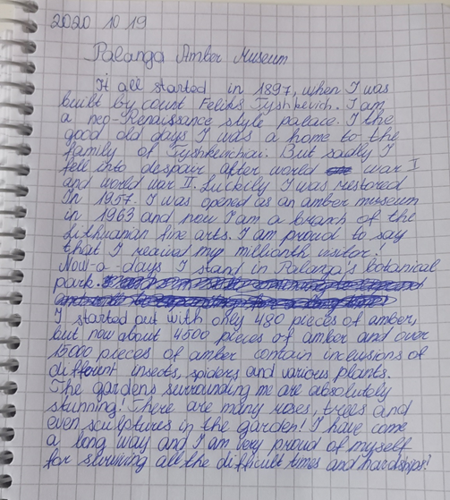

Paula Janušonytė IIC

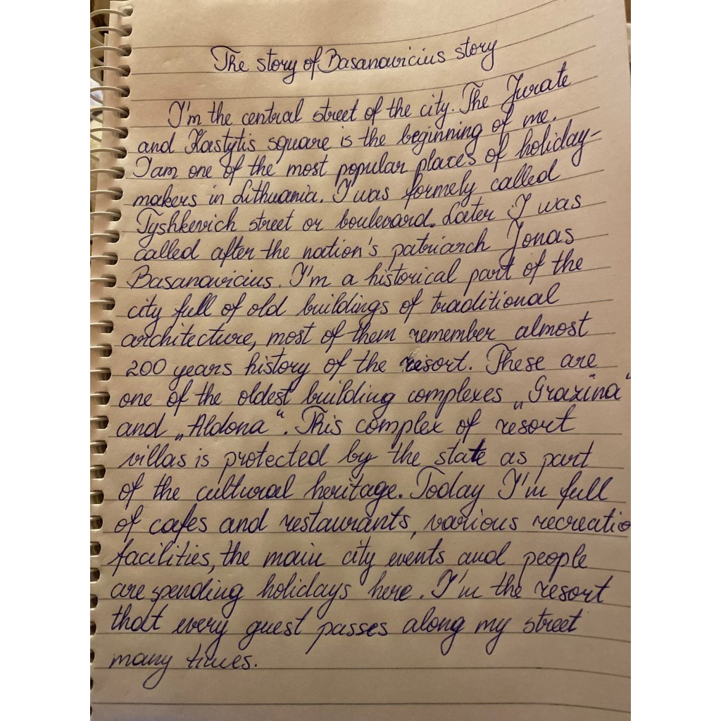

Kraniauskaitė Audra Mia IIC

The Story of the Pier

I stand in the Baltic sea, in one of the most excellent Lithuanian resorts. I am surrounded by giant waves, I hear them rustling, and it soothes me. In the summer I am the center of entertainment, and in the evening people are mostly surrounded by my charming romance. People admire not only me , but also the view of the boundless sea.

There are days when flags flutter on me. One such date was 2019. on August 23, when Palanga residents and resort guests gathered on pier to symbolically shake hands. Then the anniversary of the Baltic Way was celebrated. I am very pleased about such events.

I was built to make an attractive port, and to help develop international trade relations. My construction began in 1882 and was taken care of by Count Juozapas Tiškevičius. In the past, there were rails that transported bricks from Vilimiškės . And instead of me, the pier, was sheltered from the rain.

I am always going to be one of the most visited attractions in my resort and, to be honest, to me that is great honor. That was my history until now, I will stand here with pleasure for ages .

Žygimantas Kruša IIC

Count Mykolas Juozapas Tiškevičius in Palanga

In 1820, I visited a small fishing town on the sea shore and immediately fell in love with the place, it was suitable to establish a town for recreation and healing purposes. I could not leave that unpolished seaside diamond, so after considering all the possibilities, I met General Ksaveir Niesiolovsky and bought the Palanga manor, which was perfect for my family as a summer residence. In the summer we would stay here in Palanga and when the winter came, we would move to our Kretinga manor. After a while, I decided it was a good idea to turn Palanga into a modern seaside resort. I started building villas and my family’s summer palace. The city needed to be more active and alive, so I built a theater to be an entertaining place for guests, paths in the woods, so that guests could relax inin the nature, we assembled bathing cabins by the sea. For cold, winter days I decided to install bathing areas with heated seawater, sthat way the city could be full of vacationers all year. I also decided to build a 630-meter pier which, at that time, was the first of its kind.

Austėja Matutytė IA

The wind organ

The making of me had a very important and major goal. The "Anapilis" villa was owned by the Tiškevičiai familly, it was their recidence which they loved spending time at. Sofija Tiškevičienė, the owner's of the villa wife, was an amazing woman, though she often used to feel unwell. Therefore, to brighten up her mood her family decided to make me, the wind organ. I was built in the countess' favourite villa tower. Once she felt under the weather, she would open up the windows of the tower and listen to the lovely music that I'd make with the help of some wind. Everyone in Palanga knew that I existed but people had zero clue on how I looked like, who made me or how I even worked. My mechanism was quite simple actually. I was made out of some pairs of small tin tubes and I had tiny slits in them. Using them, I would catch the seaside winds and spread the most unusual and calming sounds that would make the villa look more mysterious and help the countess feel better. I am very unique and I don't have any analogs in Lithuania. Now, in the present day I don't work anymore due to the lack of some details that were not found during the reconstruction in 2015.

Austėja Kaziukonytė IA

Wind Organ

One day my creator sat down at the table. He sat down with a purpose to make me, a wind organs. My creator was an old, small man. He worked as a blacksmith. One evening he was asked to make something that would brighten up the mood of Countess Sofia, because her health was not very good. And this old, creative, good-hearted blacksmith started making me. He made me from very good quality metal that can withstand all the seaside winds. He worked very hard all day, matched all the sounds and eventually he created me, the wind organ. Everything was great, but I had to be transported. I was taken by an ornate young boy with a carriage. At first everything went smoothly, but later the carriage got stuck behind a log and fell to the side, then I fell out and rolled down the hill. A local homeless man heard me and took me to my creator thinking he would be rewarded for it. And so I got back in the hands of my old man. The blacksmith rocognized his work and immediately went to the Countess. And finally I was with the host. She welcomed me very happily. I was installed in the tower of the villa. When the Countess‘s health was bad, she opened the windows and listened to the melodies I had created. I had a great time composing my own songs for her.

Austėja Karkauskaitė IA

The Railway

When I was the railway station in Palanga a long time ago, I was a very important object to this town. I was at the same place where Palanga pier is now. Every day I saw different people, heard a lot of talks. Now I will tell you one of the most memorable stories of my life. As every day, I was enjoying beautiful weather, looking at new people, hearing a lot of interesting talks. While I was calculating the people passing by, I saw huge black clouds and soon a very big storm came, all the people started shouting, running around and panicking. The captain of the ship, which was loading the shipment from the train, started to shout to the crew to stop work. I was so scared because black clouds were even bigger, and the storm was even closer every minute. After 10 minutes a miracle happened - everything calmed, and the sky became clear. This situation showed me that nothing is more constant than changes.

Gabija Mikalauskaitė IA

Sofija Tiškevičienė

I was born in 1837 in Palanga. I was Lithuanian nobility, Horvart blazon noblewoman, philanthropist and countess. In 1860 I got married to Juozapas Tiškevičius, and officer of the Russian Empire, count, adjutant of the Governor General of Vilnius. The “Anapilis” villa has a terrible horror legend. I engaged in spiritualism. The room with mirrors was installed in the attic, in which I interacted with spirits. The spirits entering the room couldn’t ever leave. It’s said that not only my dead spirit acted to others, but also the spirit of the maid. Another Next legend tells has it that my daughter Sofija wanders the tower of the villa. People who have spent the night in “Anapilis” villa claim to have felt strange and inexplicable phenomena. They heard sounds and felt that in the room they were not alone, but someone was watching them.

Vaiva Getnerytė IA

Palanga fire

It was a calm morning, very sunny. The wind was unsually strong while blowing against my leaves as I prepared for another quite boring day. I’ve been in Vytautas street all my life, and never have I seen what happened that lovely morning. The first thing I heard was screaming coming from across the street in the towns rectory. Then I saw why people were so scared. There was a big fire, that the wind quickly blew onto other houses making them go up in flames in seconds. The sky within a couple minutes, turned into ash, covering me in it aswell. The fire spread uncontrollably, while all I could hear were the screams of children, women and men. All the houses that were standing next to the source of the fire, were just nothing but burnt wood and ash, while their owners were trying to pack up and leave town as soon as possible. It was sickening just standing there and watching all the chaos, while I couldn’t do anything about it.

Jokūbas Gudaitis IE

The genealogical tree of Tiskeviciai family

Hi! I'm the genealogical tree of Tiškevičiai family. I'm drawn on the wall, in one of the halls of Palanga resort museum. People who visit the museum spend a lot of time looking at me because I keep a large amount of information inside of me. I‘m one of the most interesting and informative exhibits here, I have heard how one tourist from Poland said that.
The first person placed on me is Mykolas Juozapas Tiškevičius who lived in the 19th century. He bought Palanga and started converting it into a popular resort. Such a cool guy, I feel proud of him!
Also, when visitors see the right side of me, they often wonder: "Really? Are there any descendants left?". Yes there are. Sadly, they do not live in Lithuania anymore. Most of them are in the UK now. I would be extremely happy if they came to Palanga and visited me... Who wouldn't be satisfied to see your name in the museum? Huh?
Sometimes I'm upset because I'm the exhibit which can't be moved to another place of the museum. I get really envious when some of my neighbours wave me while they are moving to another hall, for example, that swimsuit, oh... I hate it.

That is some information about me. What can I say..., my life is intersting because I meet curious people every day, but it is boring at the same time because I can‘t move at all.

Nojus Daublys IE

My life started in XVI century. I was just a piece of metal and I was deep deep underground. It was a bit cold down there. But one day I heard some weird unusual sounds. They were coming closer and closer. I thought that my last day had come when an old man found me. He was very big, muscular and with beard. As soon as he found me, he put me in his barrow and took me to the city. Later, I found he was a blacksmith. When he opened the door, I saw a fireplace, a lot of hammers and other tools. I was immediately washed because I was all dirty. It was my first bath in a hundred years. I felt as a newly born baby. Not long after that his friends came to help the man because I was a bit heavy. They put me into a furnace. It was hot as hell in there. I started to melt. After some time, when when I was soft they took me out and split me up as I was too big. After some hard work, there were dozens of my brothers. We all went back to the furnace. As soon as we became red and soft, the blacksmith took me out once again and hammered me, with all his strength. Minutes later I was flat. Then he came for my brothers. The man submerged us in water as we were too hot. When we cooled down, he put us into the furnace again, but not for too long. After that, he took me out and put a template of a coin on me and hammered it on me. All my brothers and I became the same monets with the same heads. Then he took us to the king and left us all in a chest.

Dorotėja Vindžigalskytė IE

Hello. I’m an image album and I have really old images of Palanga. Ignas Stropus made me in 1936 by. A fun fact is that I didn’t burn during the Palanga fires!

Those pictures, that are in me, are pictures of various old buildings, nature and human portraits. I have images of the old pier of Palanga, the kurhaus, the botanic garden, the Amber Museum, which wasn’t a museum back then. This town was different from what it looks like now. It was one of many villages, and the only thing that was different from other villages was that Palanga had and still has the sea. As the years passed by, the village started to grow each year. It’s a resort now. It’s one of the most popular towns for people to visit in summer! And a lot of people flock here from the biggest cities and towns of Lithuania.

I can’t wait to see what Palanga will look like in the next ten or twenty years!

Skaistė Andriekutė IC

The story of villa “Anapilis”

I was built in 1898 in a very nice place called Palanga. My architecture is very interesting and charming. I have small towers, tall windows and other unusual breathtaking accents. My first owner was Sofija Tiškevičienė, but my favorite owners were the brothers Vailokaičiai. In the past people used to spend their summer vacations and had a good time by drinking expensive liquors, chatting around, eating delicious fruits and playing forks. I really loved to be there with them. However, when dark times began, I was terrified and felt depressed, because all bad things happening around me scared me and because people destroyed my authentic looks. After those unpleasant days, I was turned into an acoustic music club. It was fun to listen to the music performed by different musicians, but it didn’t last long. Now I am the Resort Museum of Palanga and people come here to discover the history of Palanga and me. I am delighted to see that many people fall in love with me and this warm nice place called Palanga.

Arnas Drungilas IIE

At the end of the nineteenth century, I was in a factory getting ready to leave for my new home. I was not sure where I was going to end up, but I just went for it. I got loaded up on a train and travelled to the city called Palanga. As soon as I reached Palanga, I was unloaded and met a pile of other unused bricks. After staying there for a couple of days, I was finally taken by a builder, who put me as a foundation of a new house called Kurhauze. There, I met other bricks, which were put on top of me, below me, and on both sides of me. We had a great time together, but one day a disaster happened. Somehow, the whole building went into flames. I didn't know what to do, so I was sitting there and burning until I realized that bricks don't burn. After a while, firefighters put out the fire but only us bricks were left, all the wood turned into ashes. Luckily, in 2016 the building was restored, so I am still sitting here and enjoying my life.

Austėja Kuprytė IIE

The story of a medicine box

I was put on a shelf at an old pharmacy a hundred years ago. I could see every customer in the pharmacy because I was at the front of the shelf. Every time the pharmacist would walk towards me, I used to think that he was going to take me and sell me to the customers, but instead he would take the other medicine put next to me. After a long time of not being bought, I got expired and people couldn’t use me anymore. I was put in a big box of expired medicine next to the cash register. In a couple of days, there was a flu outbreak and customers started to buy the same medicine that I contained. I didn’t get to be sold, but I was displayed in the pharmacy so I could attract more customers even though I was expired.So that made me happy.

